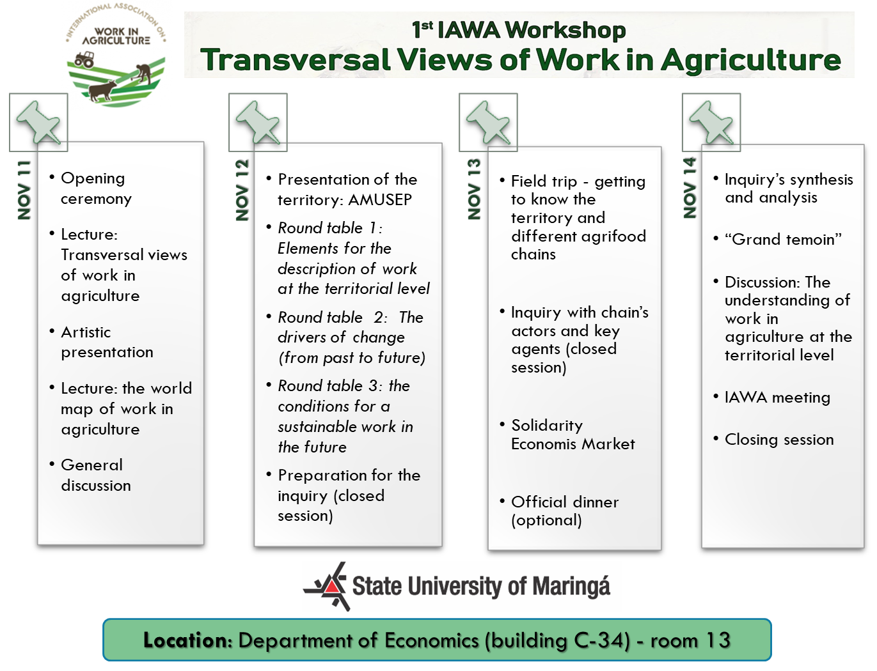
Full Program
Nov 11 – Introduction to work in agriculture in a territorial perspective
Time | Activity | Speakers
14h – 14 h30 | Opening ceremony | WS Committee
14h30 – 15h30 | Introduction: relevance of the territorial level, objective of the framework, first proposals. | Benoit Dedieu (INRA, France)
15h30 – 16h30 | Coffee Break + cultural activity
16h30 – 18h30 | The world map of work in agriculture. A bibliometric analysis of the WOS literature on work in agriculture (2008 – 2018) | Priscila Malanski (INRA, France)

Nov 12 - On the way towards a framework to analyze work in agriculture at a territorial level
Time | Activity | Speakers
8h-9h30 | AMUSEP territory: a presentation. | Marina da Silva Cunha (UEM, Brazil)  Joel C. dos Santos Filho + José Odair Mazia + Oswaldo da Silva Pádua (EMATER, Brazil)
9h30-10h | Coffee break | --
10h-12h | Round table 1: Elements for the description of work at the territorial level. | Guillermo Neiman (CONICET -CEIL, Argentine)
 |  | Ruth Nettle (Univ. Melbourne, Australia)
 |  | Astou Diao Camara (Univ. Dakar, Senegal)
 |  | Moderator: Zina Benavides (UESC, Brazil)
 |  | Reporter(s): Antoinette Dumont (Univ. Berkeley, USA)
12h-13h30 | Lunch | --
13h30-15h30 | Round table 2: The drivers of change (from past to future) | Sandra Schiavi (UEM, Brazil)
 |  | Elpidio Serra (UEM, Brazil)
 |  | Benoit Dedieu (INRA, Brazil)
 |  | Moderator: Francis Kanashiro Meneghetti (UFPR, Brazil)
 |  | Reporter(s): Carine Senger (UEM, Brazil)
15h30-16h | Coffee break | --
16h-18h | Round table 3: the conditions for a sustainable work in the future | Sylvie Cournut (Vetagrosup, France)
 |  | Sarah Lloyd (Wisconsin Food Hub Cooperative, USA)
 |  | Marcio Cassandre (UEM, Brazil)
 |  | Moderator: Marcia Lopes (UEL, Brazil)
 |  | Reporter(s): Priscila Malanski (INRA, France)

Nov 13 - On the way towards a framework to analyze work in agriculture at a territorial level (visits and inquiry)
Time | Activity | Speakers
8h - 12h | Field trip - visit of the AMUSEP region and of farms | --
12h-14h | Lunch | --
14h-16h | Inquiry: agricultural actors thinking of the future of farming (closed session) | Invited researchers + AMUSEP territory agents
16h-16h30 | Coffee break | --
16h30-18h | Discussion (closed session) | Invited researchers
14h-18h | Solidarity Economics Market – see attached programing | --
20h | Workshop dinner (optional) – price to be defined | --

Nov 14 - A framework to analyze work in agriculture at a territorial level
Time | Activity | Speakers
8h-10h | By-group synthesis of the inquiry - analysis of the process (30min per group) | Invited researchers
10h-10h30 | Coffee break | --
10h30-12h | “Grand témoin” | Dimas Soares Junior (IAPAR, Brazil)
12h-14h | Lunch | --
14h-16h | Analysis of the process and results: the understanding of work in agriculture at the territorial level; the contribution to scenarios for the future; framework and methodology: strengths and weaknesses; next steps. | WS Committee
16h-16h30 | Coffee break | --
16h30-18h | IAWA meeting | Benoit Dedieu (INRA, France) + Sandra Schiavi (UEM, Brazil)
18h-18h30 | Closing session – end of the workshop | Benoit Dedieu (INRA, France) + Julio Damasceno (UEM, Brazil)

